The Pride of Hancock

* 130 students provided with extracurricular activities that requires each student to commit to maintaining grades, discipline and excellence.
* Participation that enables most of graduating students to become eligible for band, colorguard and dance scholarships each year.
* Travels to at least three regional competitions each year where members compete against the best programs in the Southeast.

2015 AWARDS

* Rated All Superior at MHSAA – State Marching Evaluation
* Best in Class Visual, General Effect, Percussion, Music and Band at Gulf Coast Invitational



YOUR CONTRIBUTION IS TAX DEDUCTIBLE

**2-ways to sponsor**

* SPONSOR A STUDENT BY CONTRIBUTING TO THE STUDENT’S BAND DUES
* SPONSOR THE BAND BY CONTRIBUTING TO THE BANDS TRAVEL, EQUIPMENT AND INSTRUCTIONAL EXPENSES

**THE PRIDE OF HANCOCK IS EXPECTING 130 STUDENTS PARTICIPATING IN BAND, COLORGUARD, DRUMLINE AND DANCE FOR THE 2016-17 SCHOOL YEAR. YOUR SUPPORT IS VITAL TO MAINTAINING ITS AWARD WINNING PROGRAM.**

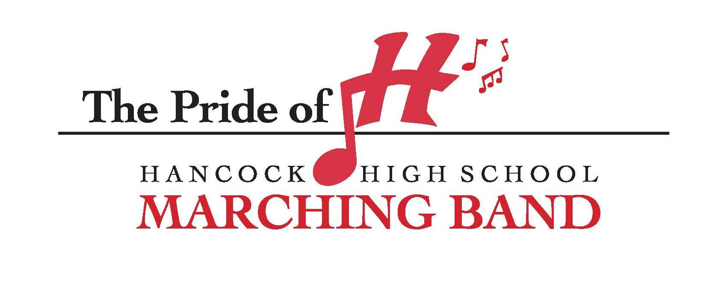

Please make checks payable to *“Friends of the Band”* and mail to:

Pride of Hancock Band Boosters

PO Box 214

Kiln, MS 39556

Federal Tax ID# 64-6000423

State Tax ID# 1168-8687

**The Pride of**

**Hancock Marching Band**



**“Friends of the Band”**

**2-ways to sponsor**

**“OFFICIAL SPONSOR”**

**$1,500 or MORE**

* Name and logo listed as “Official Sponsor” on homepage and support page of prideof hancock.com, with link to your website
* Name announced as an “Official Sponsor” at all home and away football games
* 4’x8’ sign with name and logo displayed on band tower visible to all students throughout the year
* Name and logo displayed on band equipment trailer
* 5 Pride of Hancock t-shirts
* 2 season passes for home games
* Name and logo printed on Pride of Hancock t-shirts
* Listed as Pride of Hancock Official Sponsor in 2016 HHS Football Program
* Framed Recognition Certificate for your support



**“Director”**

**$1,000 or MORE**

* Name and logo listed as sponsor on support page of prideof hancock.com, with link to your website
* Name announced at all home football games
* 4’x8’ sign with name and logo displayed on band tower visible to all students throughout the year
* Name and logo printed on Pride of Hancock t-shirts
* Listed as Pride of Hancock Official Sponsor in 2016 HHS Football Program
* Framed Recognition Certificate for your support

**__________________**

**Your sponsorship allows the Pride of Hancock to travel and compete at state and regional competitions. The Pride’s recent success has created an influx of new members that requires new equipment, repairs and additional instruction.**

**Thank you for supporting the Arts at Hancock High School!**

**“Drum Major”**

**$500 - $999**

* Name and logo listed as sponsor on support page of prideof hancock.com, with link to your website
* Name announced at all home football games
* 2’x3’ sign with name and logo displayed on band tower visible to all students throughout the year
* Name and logo printed on Pride of Hancock t-shirts
* Listed as Pride of Hancock Official Sponsor in 2016 HHS Football Program
* Framed Recognition Certificate for your support

**“Section Leader”**

**$100 - $499**

* Name and logo listed as sponsor on support page of prideofhancock.com, with link to your website
* Name and logo printed on Pride of Hancock t-shirts
* Framed Recognition Certificate for your support